Nama : Rana Ekakurnia Fathin

Kelas : Front End

Day : 13

<!DOCTYPE html>

<html lang="en">

<head>

    <!-- Google Tag Manager -->

    <script>(function(w,d,s,l,i){w[l]=w[l]||[];w[l].push({'gtm.start':

        new Date().getTime(),event:'gtm.js'});var f=d.getElementsByTagName(s)[0],

        j=d.createElement(s),dl=l!='dataLayer'?'&l='+l:'';j.async=true;j.src=

        'https://www.googletagmanager.com/gtm.js?id='+i+dl;f.parentNode.insertBefore(j,f);

        })(window,document,'script','dataLayer','GTM-TBNCVHJG');</script>

    <!-- End Google Tag Manager -->

    <meta charset="UTF-8">

    <meta name="viewport" content="width=device-width, initial-scale=1.0">

    <title>Rana Ekakurnia Fathin Portofolio</title>

    <link rel="stylesheet" href="Portofolio-Rana-Ekakurnia-Fathin.css">

    <link href="https://cdn.jsdelivr.net/npm/bootstrap@5.1.3/dist/css/bootstrap.min.css" rel="stylesheet" integrity="sha384-1BmE4kWBq78iYhFldvKuhfTAU6auU8tT94WrHftjDbrCEXSU1oBoqyl2QvZ6jIW3" crossorigin="anonymous">

    <link rel="stylesheet" href="https://cdnjs.cloudflare.com/ajax/libs/font-awesome/6.4.2/css/all.min.css" integrity="sha512-z3gLpd7yknf1YoNbCzqRKc4qyor8gaKU1qmn+CShxbuBusANI9QpRohGBreCFkKxLhei6S9CQXFEbbKuqLg0DA==" crossorigin="anonymous" referrerpolicy="no-referrer" />

</head>

<body class="bg-dark">

    <!-- Google Tag Manager (noscript) -->

    <noscript><iframe src="https://www.googletagmanager.com/ns.html?id=GTM-TBNCVHJG" height="0" width="0" style="display:none;visibility:hidden"></iframe></noscript>

    <!-- End Google Tag Manager (noscript) -->

    <!-- Welcome -->

    <div class="container-fluid d-flex justify-content-center flex-column" id="parallax-1">

        <p class="display-1 text-center align-items-center text-dark">Halo.</p>

        <p class="lead text-center align-items-center text-dark">Portofolio Front End Developer;</p>

    </div>

    <!-- About me -->

    <section class="bg-dark" id="aboutme">

        <div class="container-lg">

            <div class="row justify-content-center align-items-center">

                <div class="col-md-7 text-center text-md-start px-5">

                    <p class="display-5 text-light">About Me</p>

                    <p class="lead text-light" id="text-1">Perkenalkan nama saya Rana Ekakurnia Fathin, saat ini saya berkuliah di Universitas pembangunan Nasional Veteran Jakarta semester 5. Saya tertarik untuk belajar dan ingin memperdalam pengetahuan untuk menjadi Front End Developer. Saya harap agar dapat diterima di posisi magang sebagai Front End Developer di perusahaan anda untuk menambah pengalaman, pengetahuan, serta memperdalam kemampuan saya dalam bidang Front End Developer.</p>

                </div>

            </div>

        </div>

    </section>

    <!-- Projects -->

    <div class="container-fluid d-flex align-items-center justify-content-center flex-column" id="parallax-2">

        <p class="display-1 text-center align-items-center text-light">Projects;</p>

        <p class="lead text-center align-items-center text-light">Projek yang pernah saya kerjakan berkelompok</p>

    </div>

    <!-- Card projects -->

    <section class="bg-dark py-5">

        <div class="row row-cols-1 row-cols-md-2 row-cols-lg-2 align-items-center justify-content-center mx-5 g-5" id="projects">

            <div class="col">

                <div class="card bg-dark border-0">

                    <img src="img/projek-saku.png" class="card-img-top img-fluid" alt="...">

                    <div class="card-body">

                        <h5 class="card-title text-light">Projek Website E-Canteen</h5>

                        <p class="card-text text-light">Projek ini merupakan projek tugas akhir untuk mata kuliah praktikum pemrograman web</p>

                        <a class="btn btn-light" href="https://github.com/WOUFFY/E-Canteen-Web-SAKU" target="_blank" rel="noopener noreferrer" role="button">View</a>

                    </div>

                </div>

            </div>

            <div class="col">

                <div class="card bg-dark border-0">

                    <img src="img/projek-typingtest.png" class="card-img-top img-fluid" alt="...">

                    <div class="card-body">

                        <h5 class="card-title text-light">Projek Speed Typing Test</h5>

                        <p class="card-text text-light">Projek ini merupakan projek tugas akhir untuk mata kuliah praktikum algoritma dan pemrograman 2</p>

                        <a class="btn btn-light" href="https://github.com/WOUFFY/Speed-Typing-Test" target="_blank" rel="noopener noreferrer" role="button">View</a>

                    </div>

                </div>

            </div>

            <div class="col">

                <div class="card bg-dark border-0">

                    <img src="img/Projek-game.png" class="card-img-top img-fluid" alt="...">

                    <div class="card-body">

                        <h5 class="card-title text-light">Projek Game 2D Netherbound</h5>

                        <p class="card-text text-light">Projek ini merupakan projek tugas akhir untuk mata kuliah rancang bangun game</p>

                        <a class="btn btn-light" href="https://github.com/WOUFFY/netherbound" target="_blank" rel="noopener noreferrer" role="button">View</a>

                    </div>

                </div>

            </div>

            <div class="col">

                <div class="card bg-dark border-0">

                    <img src="img/figma.png" class="card-img-top img-fluid" alt="...">

                    <div class="card-body">

                        <h5 class="card-title text-light">Projek UI/UX Watch Sphere</h5>

                        <p class="card-text text-light">Projek ini merupakan projek tugas akhir untuk mata kuliah rekayasa perangkat lunak</p>

                        <a class="btn btn-light" href=" https://www.figma.com/proto/xFyonHbK6RqzYtLLfPT72n?node-id=1-6&starting-point-node-id=1:7&locale=en" target="_blank" rel="noopener noreferrer" role="button">View</a>

                    </div>

                </div>

            </div>

        </div>

    </section>

    <!-- Skills -->

    <div class="container-fluid d-flex align-items-center justify-content-center" id="parallax-3">

        <p class="display-1 text-center align-items-center text-light">Skills;</p>

    </div>

    <div class="container-fluid bg-dark d-flex align-items-center justify-content-center">

        <p class="h1 text-light" id="primary">Primary</p>

    </div>

    <section class="bg-dark" id="skills1">

        <div class="container-lg">

            <div class="row justify-content-center align-items-center">

                <div class="col-md-5 text-center px-5 g-5">

                    <p class="h3 text-light fw-light">HTML</p>

                    <p class="display-1 text-light"><i class="fa-brands fa-html5"></i></p>

                </div>

                <div class="col-md-5 text-center px-5 g-5">

                    <p class="h3 text-light fw-light">CSS</p>

                    <p class="display-1 text-light"><i class="fa-brands fa-css3-alt"></i></p>

                </div>

                <div class="col-md-5 text-center px-5 g-5">

                    <p class="h3 text-light fw-light">Javascript</p>

                    <p class="display-1 text-light"><i class="fa-brands fa-js"></i></i></p>

                </div>

                <div class="col-md-5 text-center px-5 g-5">

                    <p class="h3 text-light fw-light">Bootstrap</p>

                    <p class="display-1 text-light"><i class="fa-brands fa-bootstrap"></i></p>

                </div>

            </div>

        </div>

    </section>

    <div class="container-fluid bg-dark d-flex align-items-center justify-content-center">

        <p class="h1 text-light" id="secondary">Secondary</p>

    </div>

    <section class="bg-dark" id="skills2">

        <div class="container-lg">

            <div class="row justify-content-center align-items-center">

                <div class="col-md-5 text-center px-5 g-5">

                    <p class="h3 text-light fw-light">C/C++</p>

                    <p class="display-1 text-light"><i class="fa-solid fa-c"></i></p>

                </div>

                <div class="col-md-5 text-center px-5 g-5">

                    <p class="h3 text-light fw-light">Python</p>

                    <p class="display-1 text-light"><i class="fa-brands fa-python"></i></p>

                </div>

                <div class="col-md-5 text-center px-5 g-5">

                    <p class="h3 text-light fw-light">MySQL</p>

                    <p class="display-1 text-light"><i class="fa-solid fa-database"></i></p>

                </div>

                <div class="col-md-5 text-center px-5 g-5">

                    <p class="h3 text-light fw-light">Java</p>

                    <p class="display-1 text-light"><i class="fa-brands fa-java"></i></p>

                </div>

            </div>

        </div>

    </section>

    <!-- Contact -->

    <div class="container-fluid d-flex align-items-center justify-content-center" id="parallax-4">

        <p class="display-1 text-center align-items-center text-light">Contact;</p>

    </div>

    <section>

        <div class="container-fluid bg-dark d-flex align-items-center justify-content-center flex-column" id="contact">

            <p class="display-6 text-light">Silahkan hubungi:</p>

            <p class="h3 text-light fw-light">087786412484</p>

            <p class="h3 text-light fw-light">ranaekakurniafathin@gmail.com</p>

        </div>

    </section>

    <script src="https://cdn.jsdelivr.net/npm/@popperjs/core@2.10.2/dist/umd/popper.min.js" integrity="sha384-7+zCNj/IqJ95wo16oMtfsKbZ9ccEh31eOz1HGyDuCQ6wgnyJNSYdrPa03rtR1zdB" crossorigin="anonymous"></script>

    <script src="https://cdn.jsdelivr.net/npm/bootstrap@5.1.3/dist/js/bootstrap.min.js" integrity="sha384-QJHtvGhmr9XOIpI6YVutG+2QOK9T+ZnN4kzFN1RtK3zEFEIsxhlmWl5/YESvpZ13" crossorigin="anonymous"></script>

    <!-- Google tag (gtag.js) -->

    <script async src="https://www.googletagmanager.com/gtag/js?id=G-YZ08VTRTGZ"></script>

    <script>

        window.dataLayer = window.dataLayer || [];

        function gtag(){dataLayer.push(arguments);}

        gtag('js', new Date());

        gtag('config', 'G-YZ08VTRTGZ');

    </script>

</body>

</html>

Google analytic dan tag manager saya sisipkan dalam projek portofolio saya pada laman berikut https://wouffy.github.io/

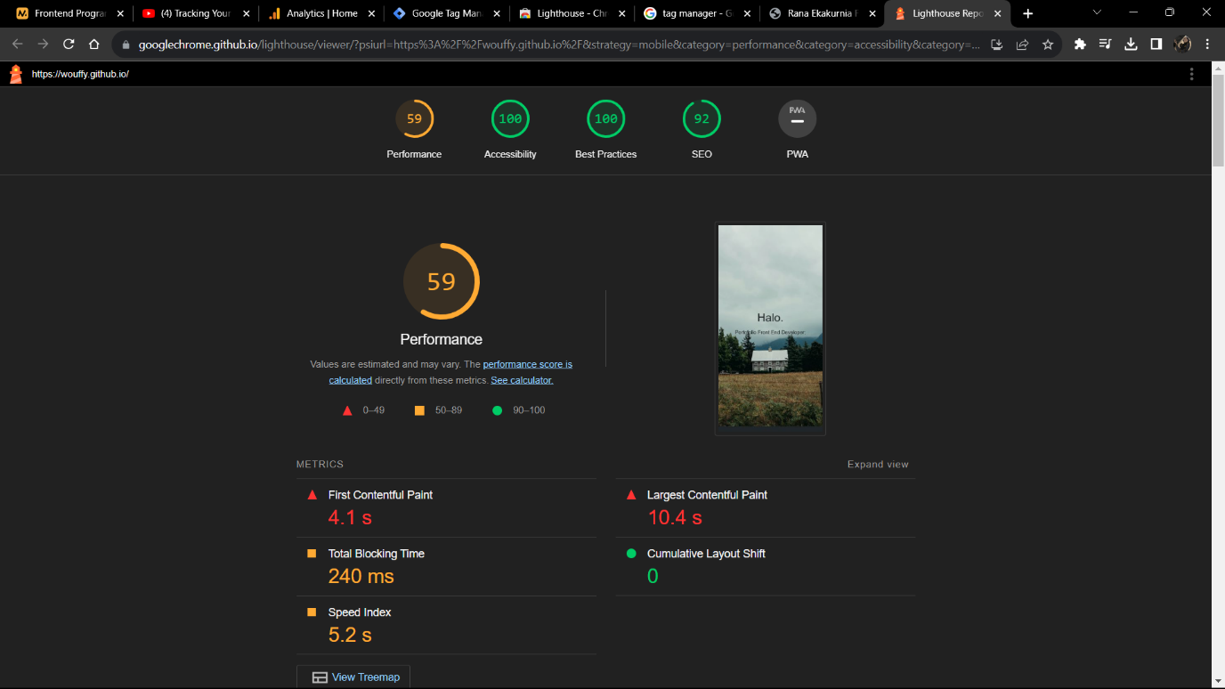

Untuk hasil lighthouse wwebsite portofolio saya dapat dilihat dlama aman berikut https://googlechrome.github.io/lighthouse/viewer/?psiurl=https%3A%2F%2Fwouffy.github.io%2F&strategy=mobile&category=performance&category=accessibility&category=best-practices&category=seo&category=pwa&utm_source=lh-chrome-ext